**Seven latest software development trends**



Constant developments have been going on in the global tech landscape. It has become crucial for businesses to stay at the top of the current developments and trends to compete. Especially for IT and software companies, it has become essential to embrace the latest software advancements and adapt to these changes. Failing to do so can make companies lose credibility among their target audience, affecting their business progress.

In the recent past, IoT, data management, and digitalization of services are some aspects that software has penetrated. It has become inevitable in the modern era to integrate software to streamline data and operational matters of businesses. With continuous development in the software industry, it has become difficult for developers and businesses to keep up with these trends. It has become crucial to understand the upcoming trends that will help you modify your business model accordingly.

Without further ado, let’s find out the latest software development trends in 2022.

**Progressive Web Apps**

A Progressive Web Application (PWA) can be accessible offline by using the previously cached data of your interactions with the app. This web application provides a seamless user experience to native mobile app and web application users.

The android app developers understood the pros and cons of mobile apps and websites. And due to that, they have come up with the idea of progressive web apps. Also, the need for password managers became essential to handle these apps to enable individuals to manage their different accounts credentials efficiently. Developers also created the best password manager android apps so that users can handle their accounts efficiently on smartphones.

**DevOps**

DevOps has become one of the best practices in the software landscape. It is the combination of operations and development that removes the barrier between the operations and the development process. The main task of DevOps is to unify the entire software application lifecycle, including development, testing, deployment, and operations.

You can consider the DevOps process as an infinite loop that consists of the duties of the development and operations team. It comprises all tasks, from coding to planning, testing to monitoring feedback.

It would be best if you looked for a competent DevOps engineer who has good experience in coding, automation, and testing with a solid teamwork background. It can make a massive contribution to the growth of your business.

**Cyber Security**

In the current era, it has become crucial more than ever to build a safe and secure digital environment. Every business has digital assets in this modern age, so implementing the latest cyber security measures is necessary.

Cyber security has become one of the major software development trends to help companies strengthen their online security against potential attacks. Developers are now more focused on creating secure web and mobile applications. It can play a key role in preventing data leaks and help companies protect their clients’ confidential information.

Any security breach can damage the reputation of a brand. Therefore, implementing cyber security practices has become integral to software development.

**Internet of Behavior (IOB)**

IOB is a data collection process based on the behavior and interests of internet users. The top companies like Facebook and Google have incorporated IOB-based data in their services to personalize search engine results and advertising targeting. It has helped businesses to create a personalized experience and channel their efforts in the right direction.

According to a research study, around 72% of consumers engage with marketing campaigns that are customized as per their interests. Also, most shoppers have stated that they only shop with brands that can offer a personalized experience. So, creating a software product with data protection and personalization features can help make a successful digital product.

**Low-code Development**

Low-code development allows companies to create apps with minimum effort as minimal coding is required. Drag-and-drop website builders have already reformed the web development landscape, which will also impact software development. Low-code development tools can help companies make the software development process [**m**](https://www.mikegingerich.com/blog/7-practical-ways-to-improve-efficiency-in-the-workplace-2/)ore efficient and less costly.

**Python**

Recently, Python has become one of the most popular and fast-growing programming languages. Software developers widely use it to create complex web applications to fulfil the needs of modern-day businesses and customers.

Companies now prefer using Python because of its ability to conduct complex data and mathematical analysis. It has become the first choice of developers for mobile app development and web development projects.

**Cloud-Native Apps**

Cloud-native apps are also expected to become the fast-growing software development trend of 2022. It allows developers to build robust and highly-functional cloud-native apps more efficiently. One of the major benefits of a cloud-native app is that you can build it using many frameworks.

**System Software**

Software is a set of programs that are used to perform a specific task. Similarly, **system software** is a set of programs that handles all the basic internal working of a computer. Moreover, it executes and controls all the working of different peripheral devices and other basic tasks and software. Examples of system software are operating systems like Microsoft Windows, Android, Linux, etc. Application software on the other hand is specific task-based software that is designed for a particular purpose only such as PowerPoint, Microsoft Word, etc. Here, we will learn in detail about the system software.

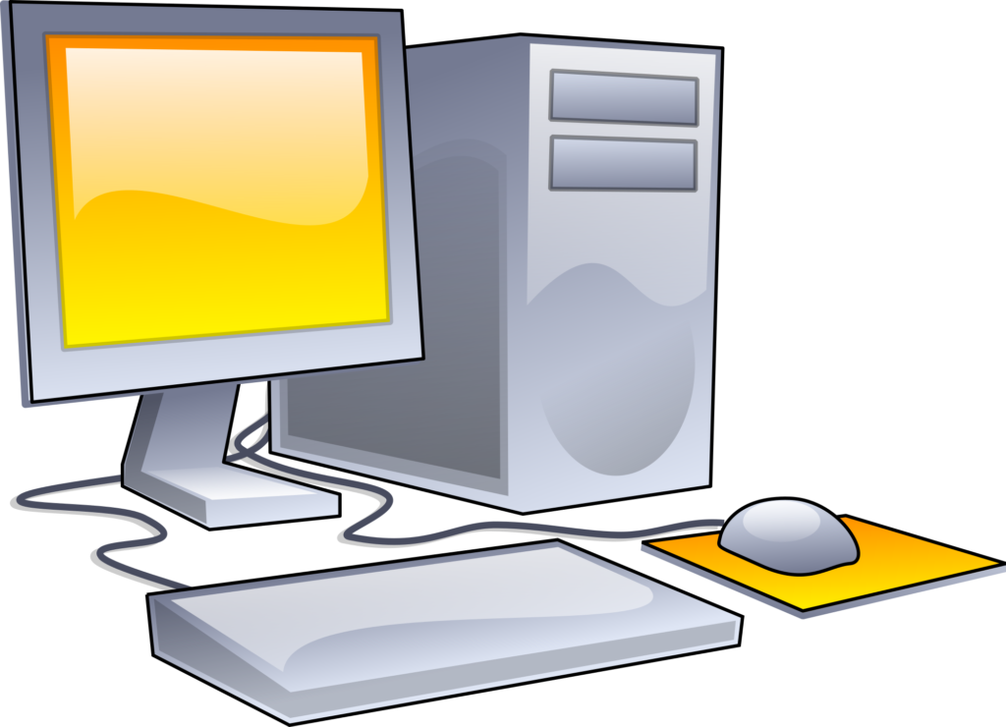

**Levels of System Software**

Let us look at some different types of system software:

**1. Operating System**

An Operating System is system software that controls the working of computer hardware and software. Moreover, it acts as a common connection between the computer hardware and software. In other words, we can also call it an interface between the hardware and the users. In addition to this, it keeps the records of all other software. Examples of operating systems are Microsoft Windows, Android, Linux, Apple iOS, Apple macOS.

Some important tasks performed by the operating system are:

**a). Scheduling**

It schedules the priority of each process using scheduling algorithms. It helps the CPU to decide which process will be executed first.

**b) Memory Management**

The operating system keeps a record of the primary memory. Moreover, when any process requires the memory, its allocation, and deallocation of the memory.

**c) File Management**

Besides memory, it also performs the function of allocating and deallocating the resources.

**d) Security**

Protects data and other software from unauthorized access through authentication.

**2. Language Processors**

It is a special type of system software that converts the source code into machine code. The input given has to be in object code only hence, we use language processors. Also, the machine code executes faster as compared to the source code.

Source Code

It is the code provided by the user. This code is in a high-level language (HLL). The computer does not understand the HLL.

Object Code

The object code is the **binary code**. As the computer understands binary language only, therefore, it is also called **machine code**.

**Different Types of Language Processors are:**

a) Assembler

It converts assembly language to machine language.

b) Interpreter

It is a type of system software that executes the program line by line.

c) Compiler

It is also a type of system software that executes the whole program at once.

**3. System Utilities**

These types of system software are used for the proper and smooth functioning of the computer system. They perform functions like removing outdated files, recover data which is accidentally lost, finding information, arranging data and files in an orderly manner, compress disk drive, install and uninstall programs, etc.

Different types of utility software are:

1. Antivirus Software

They are used to protect the system from viruses. Some examples are Quick Heal, McAfee, etc.

2. Compression Tools

They help compress large files. The files can be changed to the original form when we require it. Examples are WinRAR, PeaZip, etc.

3. Disk Management Tools

They are used to manage data on the disks efficiently so that the system performance can enhance. Examples are Disk Cleanup Tool, Backup Utility, etc.

4. Device Drivers

These types of system software are used for the operation of the peripheral devices. Each device connected to the computer has its own driver. These drivers basically contain instructions that tell the operating system how to operate the device.

Some drivers are pre-installed on the computer while some others are installed when a new device is added. The audio device, video device, scanner, camera, etc. all require a driver. A driver tells the operating system how to use the device.

**4. Application Software**

An Application Software is basically is a program or set of programs that perform a specific task. In addition to this, end-users use this software. Hence, the name end-user programs. We can also name this software as an app. There are different types of application Software both for simple as well as complex tasks.

They enable the computer to perform specific tasks like processing words, handling calculations, accounting, result preparation etc. Some basic examples are MS-Word, Photoshop, Google Chrome, etc. Let us study further about them.

**Types of Application Software**

This software has two basic categories:

1. General-purpose software
2. Customized software

**1. General-Purpose Software**

General-purpose software performs a large range of specific basic tasks. They fulfill all the general tasks that a person needs to perform on the system. There are numerous applications that a user needs to perform. Among them, some variety of applications that are frequently used comes under this category.

These can be in independent stand-alone versions or in bundles that make up application suites. Some examples of application suites can be WPS Office, MS Office, Apache OpenOffice, etc. The general-purpose software is divided further as follows:

**a) Word Processing Software**

This software contains the features to create, edit, delete, access, format, and customize text files. In addition, they have several features like thesauruses, Word Art, etc. to customize and make the files more attractive and useful.

They have additional features for publishing, sending mails, etc. Furthermore, it basically helps to create reports, letters, newsletters, manuals, books, etc.

**2. File Management System**

These utility software are used to manage files of the computer system. Since files are an important part of the system as all the data is stored in the files. Therefore, this utility software help to **browse, search, arrange, find information, and quickly preview** the files of the system.

Windows Explorer is a default file management tool present in the system. Some other examples of file management tools are Google Desktop, Double Commander, Directory Opus, etc.

**3. Compression Tools**

An important part of a computer is storage space, it is very important to maintain this storage. Therefore, we use certain utility software to compress big files and decrease their size, these are compression tools. The format of the files changes while compressing and we cannot access or edit them directly. In addition, we can easily decompress the file and get the original file back. Examples of compression tools are WinZip, WinRAR, Win Ace, Pea Zip, 7-Zip, etc.

**4. Disk Management Tools**

These utility software are used to manage data on disks. Moreover, they perform functions like partitioning devices, manage drives, etc. Examples of disk management tools are MiniTool Partition Wizard, Paragon Partition Manager, etc.

**5. Disk Cleanup Tool**

This utility software helps to free up the disk space. In addition, the files which are no longer in use are removed from the disk. Examples are Razer Cortex, Piriform Cleaner, etc.

**6. Disk Defragmenter**

This utility software helps to reduce the fragmentation and hence, reduces the access speed. Defragmenting refers to rearranging files and storing them in contiguous memory locations. Moreover, saves time in reading from files and writing files to disk. Examples of disk defragmenters are Perfect disk etc.

**7. Backup Utility**

This utility software helps to back up the files, folders,databases, or complete disks. Moreover, backup refers to duplicating the disk information so that the data can be restored if any data loss happens.